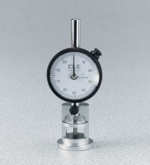 | Asphalt Flow Indicator with Brake - English  Code: 45-6892  Product Group: Marshall Stability Breaking Head, Asphalt Flow Indicator with Brake, Marshall Stability Tester

Standards
ASTM D6927, AASHTO T245

Specification
Holder | Cast aluminum.
Dial Indicator | Special type with brake.
Range | 1.00â x 0.01â divisions.
Weight | Net 12 oz. (340 g).

