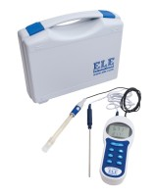 | Digital Ph/Temp/Mv Meter. with Electodes Carrying Case and Ph Buffers.  Code: 430-020  Product Group: Paqualab Test Meters

