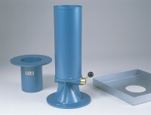 | 100mm Calibrating Container 100mm Id X 150mm Deep with 200mm Dia Rim.  Code: 29-4020  Product Group: Sand Replacement

Standards
BS 1377, BS 1924

