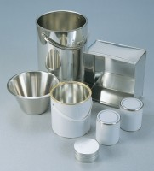 | Sample Container - Plastic 10 litres  Code: 81-3540  Product Group: Moisture Content Tin and Sample Containers

Further Information
**NOT AVAILABLE FOR SALE IN THE USA**

