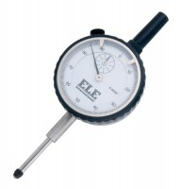 | Penetration Dial Gauge BS  Code: 24-9186  Product Group: In-situ CBR, Conversion of In-situ to Laboratory CBR, Penetration and measurement  Complete with rack extensions and chisel edge anvil.25 mm travel x 0.01 mm divisions.

