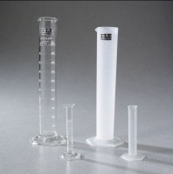 | Glass Graduated Cylinder - 10 ml Capacity  Code: 88-6000  Product Group: Glass Graduated Cylinders  10 ml capacity x 0.2 ml divisions.  Net Wt. 1 oz. (28 g).

Specification
Numbering | Double; with zero at top and bottom.
Packing | 1 cylinder/carton.

