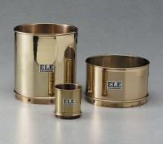 | Wet Washing Sieve - 8” diam. x 4-1/2” h. x 4” depth to mesh (203 x 114 x 102 mm).  Code: 79-7015  Product Group: Wet Washing Sieves

Standards
ASTM E11

Specification
Frame | Brass
Mesh | Stainless steel.
Weight | Net 3 lbs. (1.4 kg)

