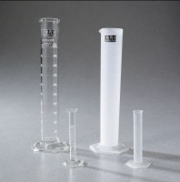 | Glass Graduated Cylinder - 100 ml Capacity  Code: 88-6007  Product Group: Glass Graduated Cylinders  100 ml capacity x 1 ml divisions.  Net Wt. 4 oz. (113 g).

Specification
Numbering | Double; with zero at top and bottom.
Packing | 1 cylinder/carton.

