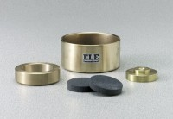 | Porous Stone 2-15/32" dia.  Code: 25-0530/10  Product Group: Floating Ring Consolidometer  2-15/32” diam. x 1/2” thick (62.7 x 12.7 mm).

