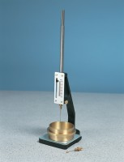 | Vicat Frame  Code: 38-2010  Product Group: Vicat Method  Complete with consistency plunger, 10 mm diameter. Requires one initial or final set needle to make up test weight to 300g.

Standards
EN 196-3, EN 13454-2, ASTM C187, ASTM C191

Further Information
**NOT AVAILABLE FOR SALE IN THE USA**

Spares/Consumables
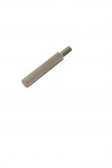 | Consistency Plunger  Code: 38-2010/10

