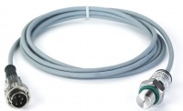 | Pressure Transducer  Code: 37-4856/10  Product Group: ADR TOUCH Digital Readout Unit Accessories  0-10,000 psi (0- 68,947 kPa) range.

