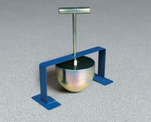 | Kelly Ball Apparatus  Code: 34-0952  Product Group: Kelly Ball Apparatus

Standards
CTM 533

Specification
Construction | Solid machined steel; rust-resistant finish.
Handle | 5" x 1/4" graduations; threads into weight.
Weight | Net 35 lbs (16 kg); Shpg. 40 lbs (18 kg).

