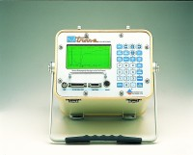 | Trase Soil Moisture Analyser  Code: 514-160/01  Product Group: TDR  With Graphic Display 150mm Wave Guide Set Power Pack & Charger

Spares/Consumables
 | Wave Guide 150mm  Code: 514-160/10

