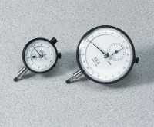 | Mechanical Dial Indicator - 25 mm Range Clockwise Movement  Code: 88-4110  Product Group: Mechanical Dial Indicators, CBR-Test 50 Machine, CBR Loading Press, Hand-Operated, Tripod Attachment, Direct/Residual Shear Apparatus

Specification
Range | 25 mm
Divisions | 0.01 mm
Movement | Clockwise
Face Diameter | 57 mm
Contact Point | Immediate response, up or down; tip movement magnified to indicator hand with minimal friction; 3/16” (5 mm) radius x 1/4” (6 mm) l.
Dials | With continuous graduations and revolution counters.
Measure Movement | Measure movement towards dial case; pointer at zero with stem extended.
Weight | Net 12 oz. (34 0 g).

Spares/Consumables
Dial Indicator - 1.0" Range
Code: 88-4100

