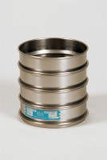 | 200mm Dia BS Sieve 12.5mm Perforated Plate.  Code: 79-1565  Product Group: 200mm Diameter BS Sieves, 200mm Diameter BS Sieves, 200mm Diameter BS Sieves

Standards
BS 410, ISO 3310

Further Information
**NOT AVAILABLE FOR SALE IN THE USA**

