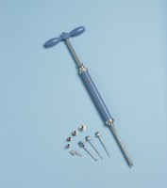 | Proctor Penetrometer Spring Type with Adaptor Stem.Supplied Complete with Set of Needle Points  Code: 29-3925  Product Group: Proctor Penetrometer, Setting Time by Penetration Resistance  Supplied without needle points

Standards
ASTM D1558

Further Information
**NOT AVAILABLE FOR SALE IN THE USA**

