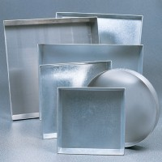 | Sample Tray - 305 mm Diameter x 50 mm  Code: 81-4700  Product Group: Sample Trays

Further Information
**NOT AVAILABLE FOR SALE IN THE USA**

