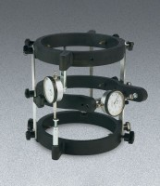 | Concrete Cyl. Compressometer - Metric  Code: 37-5626  Product Group: Concrete Cylinder Compressometer-Extensometer  With Metric reading dial indicators.

Standards
ASTM C469

Specification
Sample Size. | 6" diam. x 12" l. (152 x 305 mm)
Frame | Aluminum-magnesium alloy.
Contact Points. | Steel.
Control Rods. | Stainless steel.
Dial Indicators. | Two included.
Readability. | to 50 micor inches (0.00124 mm).
Weight. | Net 15 lbs. (6.8 kg).

