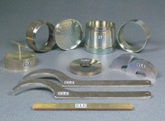 | ASTM Cutting Collar.  Code: 24-9236  Product Group: Cutting Edge, ASTM/AASHTO CBR mould and accessories  To fit ASTM CBR mould body, manufactured with a cutting edge to enable undisturbed samples to be taken in the field.

Standards
ASTM D1883, AASHTO T193

Specification
Dimensions | 6â i.d. x 1-1/2â h. (152 .4 x 38 mm).
Construction | Machined seamless steel tubing; recessed for mounting on CBR Mold.
Finish | Plated.
Weight | Net 1-1/2 lbs. (0.7 kg).

