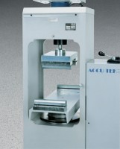 | Flexural Attachment  Code: 37-5526  Product Group: Rapid-Change Flexure Attachments, Accu-Tek Touch 500 Series

Standards
ASTM C78, ASTM C293, AASHTO T97

Specification
Loading | Center point or third point.
Blocks | Flexible to keep axes normal to specimen surface at compression point.
Lower Head | Adjusts for sample lengths of 1212â (305 mm) to 30â (760 mm).
Upper Head | Uses toe hitch design to mount to upper crosshead.
Weight | Net 175 lbs. (79 kg).

