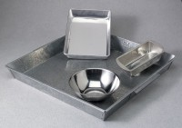 | Mixing Pan - Round Stainless - 7-3/4" x 3"  Code: 88-7170  Product Group: Mixing Pans and Bowls  Stainless steel; 7-3/4" diam. x 3" deep (197 x 76 mm).

