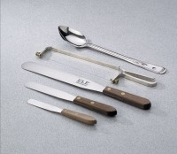 | Spatula - 10" Length  Code: 88-7520  Product Group: Spatulas  10” l. x 1-1/4” w. (254 x 32 mm) blade.

Specification
Handle | Wood.
Blade | Stainless steel.
Weight | Net 2 oz. (56 g).

