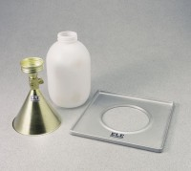 | Plastic Sand Jug  Code: 29-4292/10  Product Group: Sand Density Cones

Standards
ASTM D1556, AASHTO T191

