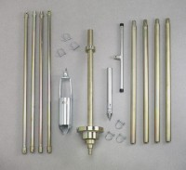 | Portable Dynamic Cone Penetrometer/Auger Set  Code: 29-5500  Product Group: Portable Dynamic Cone Penetrometer/Auger Set  Consists of sliding drive hammer assembly, cone penetrometer point attached to a 12” (305 mm) rod, four 30” (762 mm) “E” drill rod extensions, Tee Handle, auger head and 4 auger extensions

Specification
Auger Head | 3-1/4â (82.6 mm) bucket diam. 4â (102 mm) blade diam.
Tee Handle | 3/4â (19 mm) diam. rod; 36â (914 mm) long.
Extensions | Four 36â (914 mm) hand auger extensions.
Slide Hammer | 15 lb. circular disc with 20â (508 mm) free fall.
Hammer Extensions | Four 30â (762 mm) E Drill rods.
Penetrometer Cone | 30Â°.
Weight | Net 78 lbs. (35 .4 kg).

Spares/Consumables
 | 3-1/4" Auger Head  Code: 23-1400/10
30" Drill Rod with Extensions
Code: 29-5500/12
Auger Extensions 36"
Code: 23-1400/12
Cone Penetrometer Point
Code: 29-5500/11
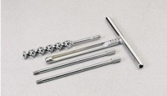 | Connector Pin  Code: 23-1400/13
Sliding Drive Hammer Assembly
Code: 29-5500/10
Tee Handle
Code: 23-1400/11

