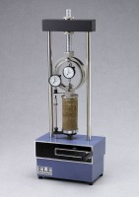 | Unconfined Compression Platens. for Use on Ele Load Frames Max Sample Dia 95mm.  Code: 25-3650  Product Group: N/A

Standards
ASTM D2166, AASHTO T208, BS 1377, BS 1924, EN 13286-47, ASTM D1883, AASHTO T193

