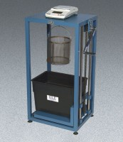 | Density of Coarse Aggregates Set  Code: 4204/02  Product Group: Density of Coarse Aggregates Set  Set Includes:  1 Buoyancy Balance, 8100 g (42-1000/02).  1 ASTM C-127 Density Basket (42-1003).  1 8” Brass Sieve #4 Mesh (79-5020).  1 Pan, Galvanized (88-7150).

Standards
ASTM C127, AASHTO T85

Further Information
110vAC, 50/60Hz, 1ø.

