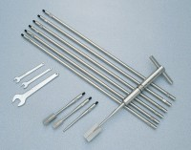 | H60 Field Inspection Vane Tester 0-200Kpa In Carrying Case. includes calibration and certificates.  Code: 26-3335  Product Group: Inspection Vane  This instrument is an essential tool for civil engineers involved in site investigation work. The unit is supplied in kit form with a carrying case incorporating the measuring head, extension rods, vanes, etc. The measuring head comprises a T-handle that is spring-loaded against the extension rod adaptor. Weight 3 kg.

Further Information
Range 0 to 260 kPa, in carrying case with 6 x 0.5 metre extension rods, 3 vanes, dummy vane and tools. Supplied complete with Calibration Certificate.

Spares/Consumables
 | H605 Extension Rod 0.5M and connection piece  Code: 26-3335/11

