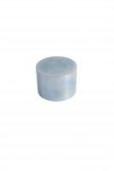 | Steel Block  Code: 45-6463  Product Group: Accessories for manual and automatic compaction  100 mm diameter x 50 mm height. For heating the compaction hammer foot.

Standards
EN 12697-30

Further Information
**NOT AVAILABLE FOR SALE IN THE USA**

Spares/Consumables
 | Baseplate  Code: 45-6310/11
Compaction Mould Body
Code: 45-6310/10

