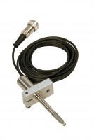 | Consolidation Transducer Assembly 15mm Travel Fitted with 5 Pin Din Plug.  Code: 27-1649  Product Group: Displacement Transducers, Vertical settlement measurement, Displacement Measurement  Fitted with 5 pin DIN plug.

Specification
Construction | Fully encapsulated electronics,  sealed in a stainless steel case
Excitation | 11 V DC
Connector | 5-pin DIN type
Mounting bracket | Included as standard
Weight kg | 0.45
Construction | Fully encapsulated electronics, sealed in a stainless steel case.
Excitation | 10vDC.
Connector | 5-Pin DIN type.
Mounting Bracket | Included as standard.
Weight | Net 1 lb. (0.45 kg).

