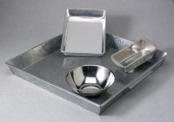 | Mixing Pan - Aluminum - 9-3/4" x 1-1/2"  Code: 88-7190  Product Group: Mixing Pans and Bowls  Aluminum; 9-3/4" diam. x 1-1/2" (248 x 38 mm).

