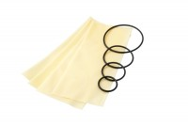 | Rubber Membrane 50mm Diameter Pack of 10.  Code: 25-5441  Product Group: Rubber Membranes  50 mm diameter rubber membrane (Pack Of 10).

