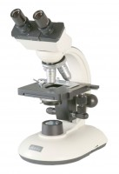 | Binocular Microscope 45 Deg Inclined 360 Deg Rotating Head Wf10X Eye- Piece 4X 10X & 40X  Code: 550-035/01  Product Group: General laboratory instrumentation

