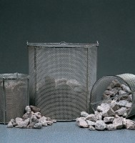 | Wire Basket - 3.35 mm wire mesh  Code: 81-4825  Product Group: Soundness of Aggregates, Wire Baskets

Further Information
**NOT AVAILABLE FOR SALE IN THE USA**

