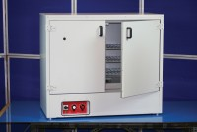 | 225 Litre Drying Oven  Code: 78-1250/01  Product Group: Percentage Refusal Density (PRD), Oven Drying Method, Oven Drying Method, Oven Drying Method

Standards
EN 12697-32, EN 13280-4, BS 598-104, BS 1377

Specification
Capacity | 225 litres
External Dimensions (l x w x h) | 540 x 1040 x 940
Internal Dimensions (l x w x h) | 440 x 920 x 600
Fluctuation | ± 0.75°C
Rated power heater elements | 2000 W
Shelves supplied | 3
Shelf positions | 4
Weight | 80 kg

