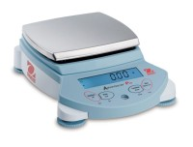 | High Capacity Electronic Balance  Code: 88-1094/02  Product Group: Specific Gravity (Rice) Test with 2,000 gram Vacuum Pyknometer, Specific Gravity (Rice) Test with 6,000 gram Vacuum Pyknometer, Ohaus Series Electronic Balances

Further Information
15,000 gram capacity x 0.05 grams, 100-240V 50/60 Hz

Specification
Maximum Capacity | 15000 g
Readability | 0.05 g
Repeatability (Std. Dev.) | 0.1 g
Linearity | +/-0.15 g
Internal Calibration | NO
Pan Size (in/cm) | 9.5 x 13 .8 in / 24 0 x 35 0 cm
Dimensions w x h x d (in/cm) | 14 .2 x 14 .6 x 4.5  in / 36 x 37  x 11 .5 cm
Shipping Wt. (lb/kg) | 24 lb / 10.6  kg

