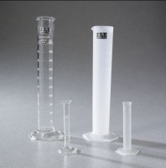 | Graduated Cylinder  Code: 88-6012  Product Group: Glass Graduated Cylinders, Bitumen Extraction Test  1000 ml

Further Information
2 units required for Bitumen Extraction Test.

Specification
Numbering | Double; with zero at top and bottom.
Packing | 1 cylinder/carton.

