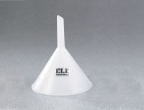 | Plastic Funnel - 2" top diam.  Code: 88-7200  Product Group: Plastic Funnels  2" (51 mm) top diam.; 1-1/2" (38 mm) stem.

Specification
Materials | Conventional polyethylene; non-toxic, non-contaminating; withstands nearly all chemicals at room temperature for 24 hrs.
Temperature Tolerances | 176Â°F (80Â°C) maximum; -148Â°F (-100Â°C) brittleness.

