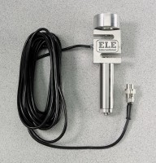 | S-Type Load Cell 500 lb Capacity  Code: 27-1581  Product Group: S-Type Load Cell  (2.2 kN) capacity. Net wt. 1 lb. (0.45 kg).

Specification
Excitation | 10vDC.
Output | 3.0 mV/V minimum.
Non-Linearity | 0.03% full scale output.
Hysterisis | 0.02% full scale output.
Bridge Resistance | 350 ohms nominal.
Overload Capacity | 150%.
Mounting Hardware | Includes all necessary hardware for mounting to the Tritest 50 and Versa-Loader load frames.

