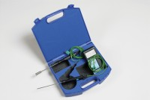 | Digital Thermometer  Code: 82-5442  Product Group: Hand-held Digital Thermometers  Range -75 - 1200°C

Further Information
**NOT AVAILABLE FOR SALE IN THE USA**

Specification
Range | –75 to +1200ºC or –30 to  +199.9ºC or –75 to +1999ºF
Resolution and accuracy | 1ºC (–75 to +1200ºC), 0.2% ± 0.1ºC, 0.1ºC (–30 to +199.9ºC) 0.2% ± 1.0ºC, 1ºF (–75 to +1999ºF), 0.2% ± 2.0ºF
Cold junction (automatic) | 0 to 45ºC
Weight | 500 g

