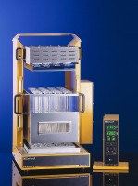 | Digestion Unit 20 Place Semi-Auto C/W Block Rack Heat Shield Exhaust Console & 250Ml Tubes  Code: 525-356/01  Product Group: Kjedahl apparatus  Supplied with digestion block, carrying rack with heat shield, exhaust system, two-tier console, instruction manual and 20 digestion tubes, 250 ml, 300 x 42 mm.

Further Information
For 220-240 V, 50/60 Hz, 1 ph.

Spares/Consumables
 | Digestion Tube Macro 250Ml  Code: 525-355/10

