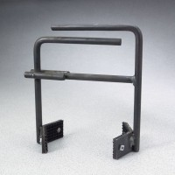 | Heavy-Duty Cylinder Carrier  Code: 34-5300  Product Group: Heavy Duty Cylinder Carrier

Specification
Construction | Steel
Weight | Net 3 lbs (1.3 kg)

