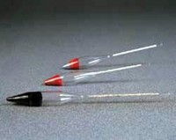 | Hydrometer  Code: 82-3510  Product Group: Hydrometers, Aggregate Testing, Soundness of Aggregates  Type L50, ASTM C 88 graduated 1150 to 1200 relative density (used with magnesium sulphate method).

Standards
BS 812, EN 1367-2, ASTM C88, AASHTO T104

Further Information
**NOT AVAILABLE FOR SALE IN THE USA**

