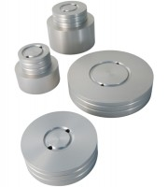 | 50mm Base Adaptors for 70mm Cells.  Code: 25-4174  Product Group: Base Pedestals, Specimen Base Adaptors  50mm Base Adaptor with Twin Pore Pressure Ports for 70mm Cells.

Standards
BS 1377, ASTM D2850, ASTM D4767, AASHTO T296, AASHTO T297

