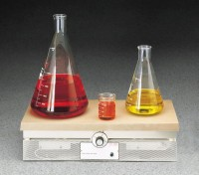 | Hot Plate 288 sq. in.  Code: 88-0530/02  Product Group: Hot Plates  120vAC, 50/60 Hz, 1ø. 3,200 Watts.

Specification
Temperature Range | 100Â°F to 700Â°F (38Â°C to 371Â°C).
Thermostatic Control | Demand-type; holds heating surface to  Â±3Â°C at 371Â°C; with indicator light.
Top Plate | Cast aluminum; 24 â w. x 12 â d. (610 x 305 mm).
Case | Stainless steel.
Overall Dimensions | 24 â w. x 13 â d. x 6-1/8â h. (610 x 33 0 x 156 mm).
Weight | Net 35 lbs. (15 .8 kg).

