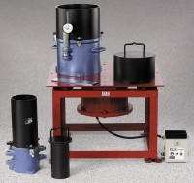 | Density Set 50 Hz  Code: 2500/01  Product Group: Vibrating Tables  Set Includes:  1 Vibrating Table (24-9112/01).  1 0.1 cu. ft. Relative Density Mold Set (24-9114).  1 0.5 cu. ft. Relative Density Mold Set (24-9116).  1 Relative Density Gauge Set (24-9118).

Standards
ASTM D4253, ASTM D4254

Further Information
220vAC, 50 Hz, 1ø.

