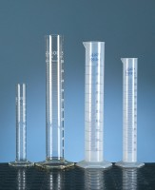 | Measuring Cylinder - Plastic 250 ml  Code: 82-1860  Product Group: Measuring Cylinders, BS  Plastic with spout, graduated to BS 5404.

Further Information
**NOT AVAILABLE FOR SALE IN THE USA**

