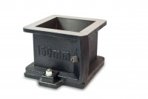 | 150mm Cube Mould 2-Part Clamp Type. Cast Iron Construction. BS EN Compliant.  Code: 34-4670  Product Group: Cube Moulds  2-part with clamp attached base plate.

Specification
Construction | Bolted sides and clamped base plate
Finish | Painted
Weight | 42 lb (19.1 kg)

