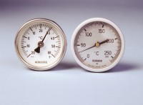 | Portable Thermometer -20 - +60°C  Code: 82-5246  Product Group: Portable Dial-type Thermometers  50 mm diameter dial with a 200 mm long stem and protective sheath.

Further Information
**NOT AVAILABLE FOR SALE IN THE USA**

