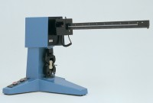 | 10kN Flexural/Tensile Testing Machine  Code: 39-7100/01  Product Group: 10 kN Flexural/ Tensile Testing Machine  This single lever machine is designed for flexural tests on 40.1 x 40 x 160 mm mortar prisms and tensile tests on mortar briquettes. The rate of applied loading for flexural testing is to EN196-1. Load is applied by a weight travelling along the beam at a constant rate, driven by a motor/gearbox. Readings are made by means of a cursor visible through a window in the moving weight. Failure of a specimen triggers a switch mechanism and brings the weight to a halt immediately. To prevent overloading, a sensor is incorporated in the weight and automatically stops the machine at its maximum capacity of 10 kN. Supplied complete with flexural and tensile jaws.

Standards
EN 196-1

Further Information
**NOT AVAILABLE FOR SALE IN THE USA**
For 220 - 240 V AC, 50 Hz, 1 ph.

