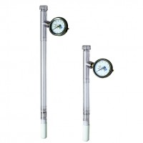 | Dial-Type Gauge Tensiometer 900 mm  Code: 514-024  Product Group: Tensiometers  900 mm Long

Further Information
Requires Part 514-034

